**Installing the ESP32 Board in Arduino IDE (Windows, Mac OS X, Linux)**

There’s an add-on for the Arduino IDE that allows you to program the ESP32 using the Arduino IDE and its programming language. In this tutorial we’ll show you how to install the ESP32 board in Arduino IDE whether you’re using Windows, Mac OS X or Linux.

**Watch the Video Tutorial**

*https://youtu.be/mBaS3YnqDaU*

## Prerequisites: Arduino IDE Installed

Before starting this installation procedure, make sure you have the latest version of the Arduino IDE installed in your computer. If you don’t, uninstall it and install it again. Otherwise, it may not work.

Having the latest Arduino IDE software installed from [arduino.cc/en/Main/Software](https://www.arduino.cc/en/Main/Software), continue with this tutorial.

## Installing ESP32 Add-on in Arduino IDE

To install the ESP32 board in your Arduino IDE, follow these next instructions:

1. In your Arduino IDE, go to **File**> **Preferences**

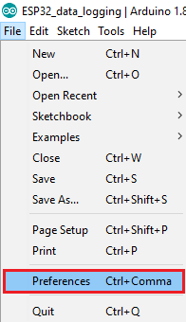

1. Enter **https://dl.espressif.com/dl/package_esp32_index.json** into the “Additional Board Manager URLs” field as shown in the figure below. Then, click the “OK” button:

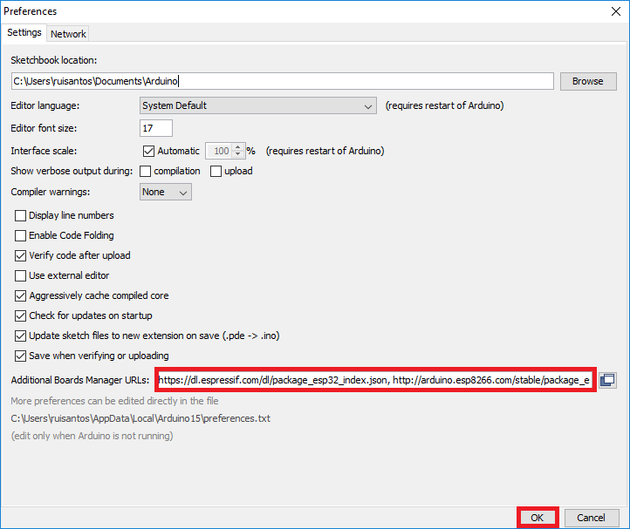

**Note:** if you already have the ESP8266 boards URL, you can separate the URLs with a comma as follows:

https://dl.espressif.com/dl/package_esp32_index.json, http://arduino.esp8266.com/stable/package_esp8266com_index.json

1. Open the Boards Manager. Go to **Tools** > **Board** > **Boards Manager…**

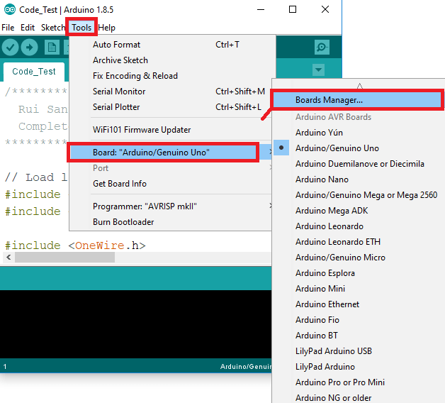

1. Search for **ESP32** and press install button for the “**ESP32 by Espressif Systems**“:

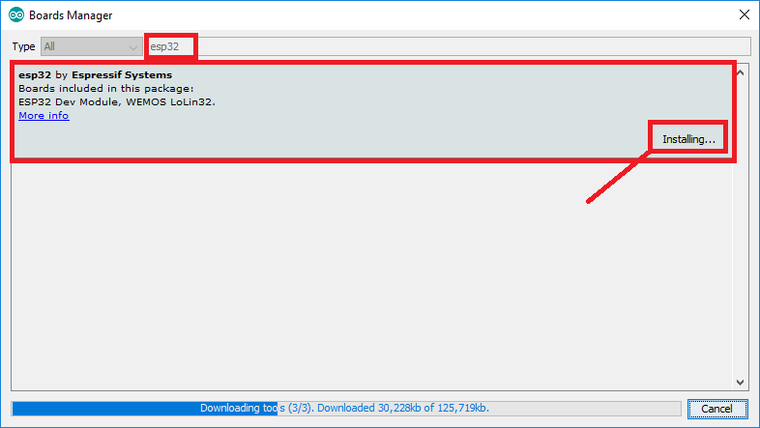

1. That’s it. It should be installed after a few seconds.

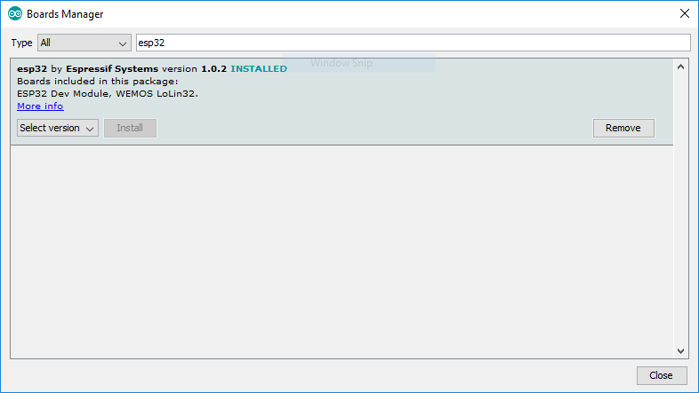

## Testing the Installation

Plug the ESP32 board to your computer. With your Arduino IDE open, follow these steps:

1. Select your Board in **Tools** > **Board** menu (in my case it’s the **DOIT ESP32 DEVKIT V1**)

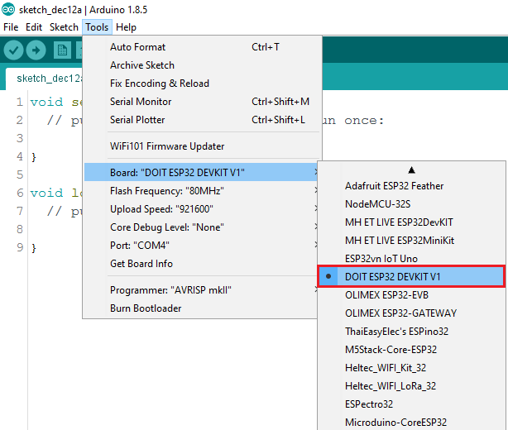

2. Select the Port (if you don’t see the COM Port in your Arduino IDE, you need to install the [CP210x USB to UART Bridge VCP Drivers](https://www.silabs.com/products/development-tools/software/usb-to-uart-bridge-vcp-drivers)):

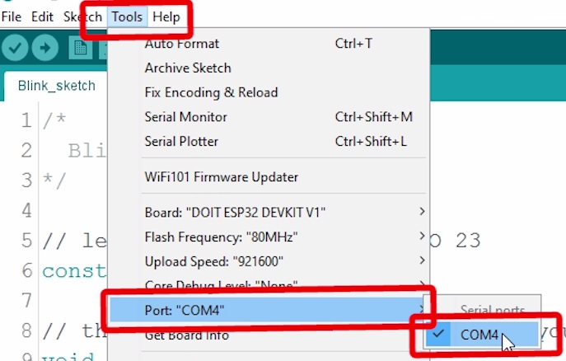

3. Open the following example under **File** > **Examples** > **WiFi (ESP32)** > **WiFiScan**

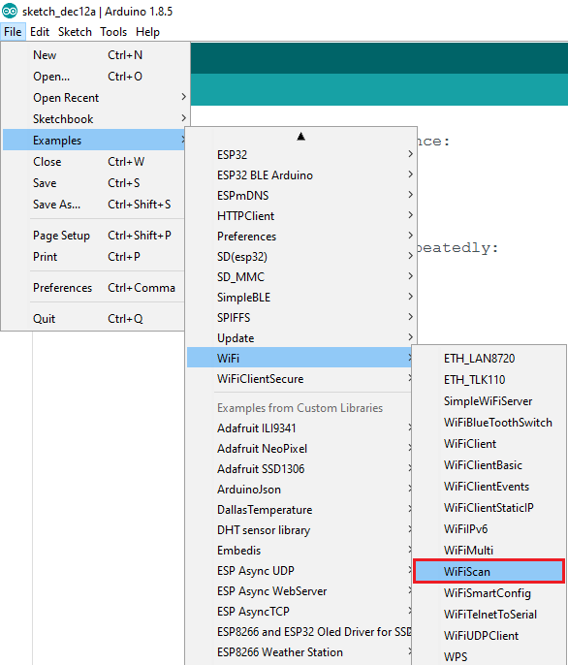

4. A new sketch opens in your Arduino IDE:

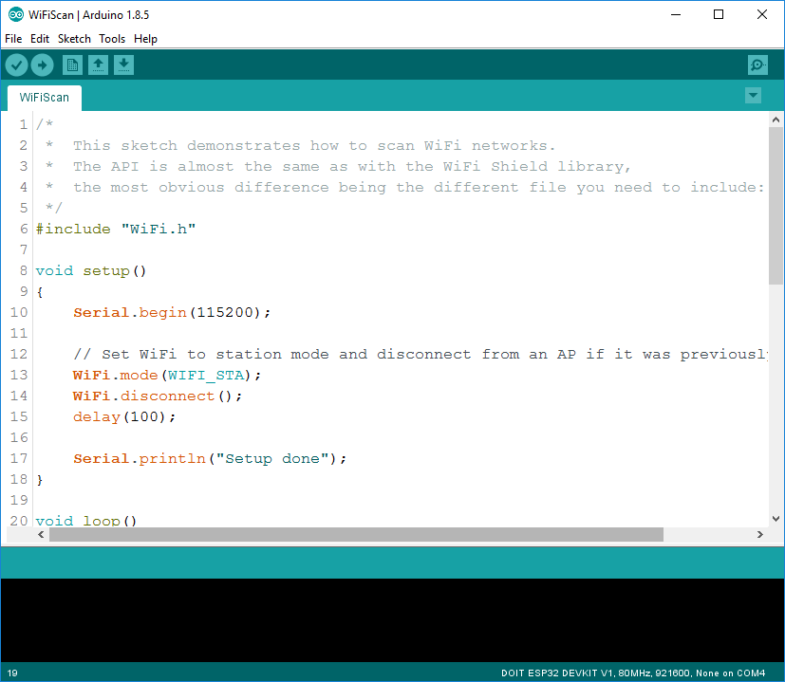

5. Press the **Upload** button in the Arduino IDE. Wait a few seconds while the code compiles and uploads to your board.

Arduino IDE upload WiFiScan sketch to ESP32

6. If everything went as expected, you should see a “**Done uploading.**” message.

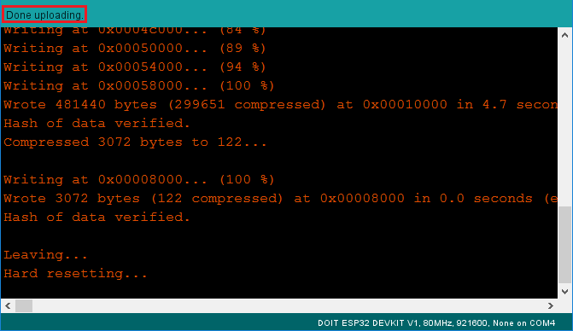

7. Open the Arduino IDE Serial Monitor at a baud rate of 115200:

Open Arduino IDE Serial Monitor at baud rate 115200

8. Press the ESP32 on-board **Enable** button and you should see the networks available near your ESP32:

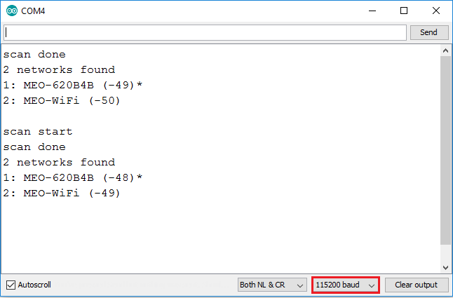

**Troubleshooting**

If you try to upload a new sketch to your ESP32 and you get this error message “*A fatal error occurred: Failed to connect to ESP32: Timed out… Connecting…*“. It means that your ESP32 is not in flashing/uploading mode.

Having the right board name and COM por selected, follow these steps:

* Hold-down the “**BOOT**” button in your ESP32 board

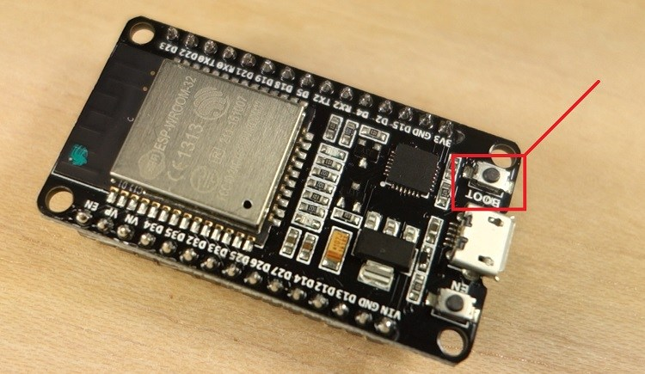

* Press the “**Upload**” button in the Arduino IDE to upload your sketch:

Arduino IDE uploading new sketch to ESP32

* After you see the  “**Connecting….**” message in your Arduino IDE, release the finger from the “**BOOT**” button:

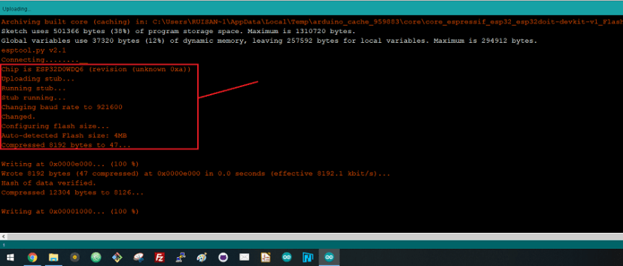

* After that, you should see the “**Done uploading**” message

That’s it. Your ESP32 should have the new sketch running. Press the “**ENABLE**” button to restart the ESP32 and run the new uploaded sketch.